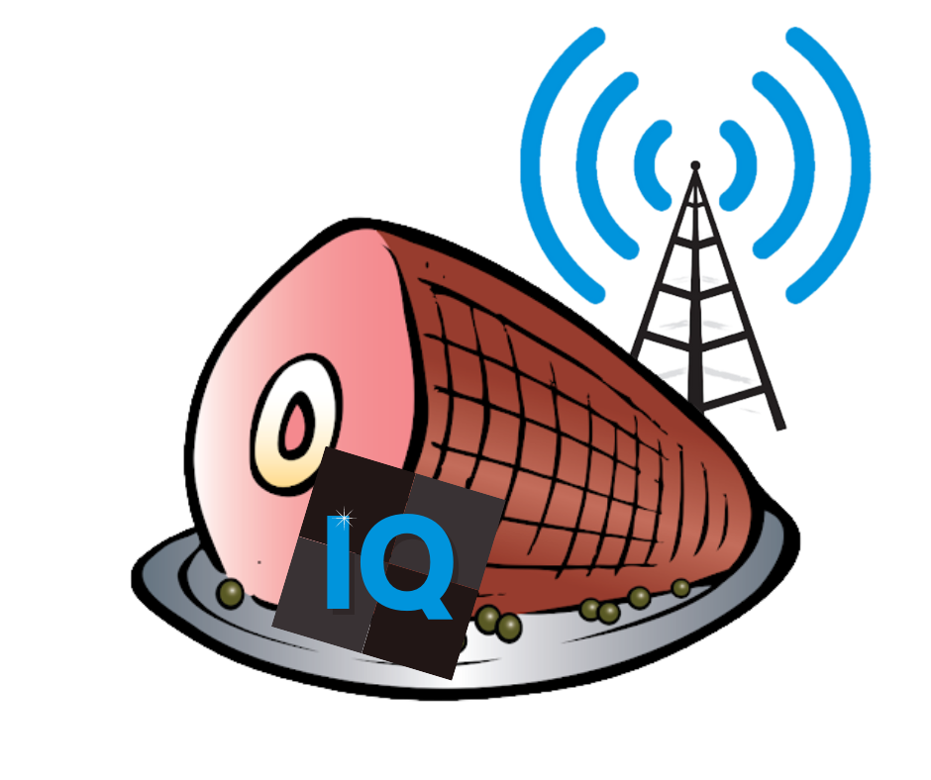Fellow Hams and Inovato Quadra Enthusiasts, I am pleased to announce the release of *HamIQ* 3.1.2b1 (November 2022) – The Inovato Quadra Ham Radio Image I've been working on for more than three years.

I have confirmed this image starts up successfully on the Inovato Quadra Plus.

A BIG thank you to my XYL, Michelle, for creating the HamIQ Logo!

For community support, please visit <https://groups.io/g/Inovato-Quadra-4-HamRadio>

-Dave Slotter, [W3DJS](https://www.qrz.com/db/W3DJS)

HamIQ 3.1.2b1 – The Inovato Quadra Ham Radio Image by W3DJS

General Ham Radio Applications

[HamLib](https://hamlib.github.io/) - Ham Radio Control Libraries

[grig](http://sourceforge.net/projects/groundstation) - graphical user interface to the Ham Radio Control Libraries

[CHIRP](https://chirp.danplanet.com/) - Radio Programming Software

[APRS Message App for JS8Call](http://m0iax.com/2019/09/25/aprs-message-app-for-js8call/) - GUI to send APRS messages via JS8Call

[QTel](https://www.svxlink.org/) - EchoLink client

[QSSTV](http://users.telenet.be/on4qz/index.html) - Slow Scan TV (e.g. "Fax")

[Gpredict](http://gpredict.oz9aec.net/) - Satellite prediction

[FreeDV](https://freedv.org/) - Free digital voice vocoder

[BlueDV](https://www.pa7lim.nl/bluedv/) - Client for D-Star and DMR

[WsprryPi - WSPR software](https://github.com/8cH9azbsFifZ/WsprryPi.git)

[ADS-B Flight Tracking Software](https://github.com/MalcolmRobb/dump1090)

[Pi3/4 Stats Monitor](http://www.w1hkj.com/pi3/) - by [W1HKJ](http://www.w1hkj.com/)

[VOACAP](https://www.qsl.net/hz1jw/voacapl/index.html) - HF propagation prediction

[GPS Support](https://gpsd.gitlab.io/gpsd/)

[wxtoimg](https://wxtoimgrestored.xyz/beta/) - NOAA weather imaging software

[twHamQTH](http://wa0eir.bcts.info/twhamqth.html) - an online callsign look up program

[twclock](http://wa0eir.bcts.info/twclock.html) - a world clock and automatic ID for amateur radio operators

[acfax](https://www.qsl.net/dl4sdc/) - Receive faxes using your radio and sound card

[colrconv](http://db0fhn.efi.fh-nuernberg.de/doku.php?id=radio:db0fhn:convers)  -  convers client with sound and ncurses color support

[D-Rats 0.3.9 (by new maintainer Maurizio Andreotti)](https://github.com/maurizioandreotti/D-Rats) - A communication tool for D-STAR

[fbb](http://www.f6fbb.org/) - Packet radio mailbox and utilities

gcb - Utility to calculate long and short path to a location

[glfer](https://www.qsl.net/in3otd/) - Spectrogram display and QRSS keyer

[Xdx](https://github.com/N0NB/xdx) is a DX-cluster client

[DXSpider](http://www.dxcluster.org/main/) - DX Cluster Server

[fccexam](https://www.qrz.com/db/AC6SL) - Study tool for USA FCC commercial radio license exams.

[gnuais / gnuaisgui](https://github.com/rubund/gnuais/) - GNU Automatic Identification System receiver

[hamexam](https://www.qrz.com/db/AC6SL) - Study guide for USA FCC amateur radio (ham radio) license examinations.

[hamfax](http://hamfax.sourceforge.net/) - Qt based shortwave fax

[inspectrum](https://github.com/miek/inspectrum) - tool for visualising captured radio signals

[predict-gsat](https://github.com/kd2bd/predict/) - Graphical Predict client

[splat](http://www.qsl.net/kd2bd/splat.html) - analyze point-to-point terrestrial RF communication links

[wwl](https://www.qrz.com/db/VA3DB) - Calculates distance and azimuth between two Maidenhead locators

[AX.25](https://github.com/ve7fet/linuxax25) – Packet Radio drivers for ax.25 protocol

[linpac](https://sourceforge.net/projects/linpac) - terminal for packet radio with mail client

[PyBOMBS](https://github.com/gnuradio/pybombs) - GNU Radio install management system

[AMBEServer](https://github.com/marrold/AMBEServer) – AMBE vocoder chip support

[HamClock](https://www.clearskyinstitute.com/ham/HamClock/) – GUI HamClock by WBOEW

[Adifmerg](https://github.com/oh7bf/adifmerg) – command-line ADIF conversion utility

[Lopora](https://www.qsl.net/pa2ohh/11lop.htm) – QRSS Beacon Reception

[Universal Ham Radio Remote](https://github.com/F4HTB/Universal_HamRadio_Remote_HTML5) (UHRR) – UHRR provides remote radio operation

[ACARS Decoder](https://github.com/TLeconte/acarsdec) – for tracking aircraft transponders

[CygnusRFI](https://github.com/0xCoto/CygnusRFI) – RFI analysis tool for ground stations and radio telescopes)

[Update Scripts](https://github.com/dslotter/ham_radio_scripts) -- to update Fldigi suite and WSJT-X (so one doesn't have to wait for new HamPi release.)

[Radio Explorer](http://www.radioexplorer.com.ru/en/) – Displays shortwave radio broadcast schedules

[QrssPiG](https://gitlab.com/hb9fxx/qrsspig) – QRSS (Raspberry) Pi Grabber

[Minimodem](http://www.whence.com/minimodem/) – General purpose software audio FSK modem

[Orca](https://help.gnome.org/users/orca/stable/) – Screen-reading software which supports blind hams

[RBNC](https://dm3mat.darc.de/rbn/) – Reverse Beacon Network Client

[QDMR](https://dm3mat.darc.de/qdmr/) – a GUI application and command line tool to program DMR radios

[wfview](https://wfview.org/) – a program to control modern Icom ham radios

[DroidStar](http://www.dudetronics.com/index.php/droidstar) – Software to RX/TX D-STAR, DMR, Fusion YSF/FCS, NXDN, P25, M17, and IAX (AllStar client)

[Lady Heather](http://www.ke5fx.com/heather/readme.htm) – GPS Monitoring software

[Cqrprop](https://github.com/ok2cqr/cqrprop) – Small application that displays propagation data from Paul, N0NBH website

Antenna Ham Radio Applications

[antennavis](http://www.include.gr/antennavis.html) - Antenna Visualization Software

[Atlc](http://atlc.sourceforge.net/)l – Arbitrary Transmission Line Calculator

[gsmc](https://github.com/radioteknos/gsmc.git) - A GTK Smith Chart Calculator for RF impedance matching

[nec2c](https://www.qsl.net/5b4az/) - Translation of the NEC2 FORTRAN source code to the C language

[xnecview](http://www.pa3fwm.nl/software/xnecview/) - NEC structure and gain pattern viewer

[yagiuda](https://www.dhars.org.uk/members_pages/G8WRB/) - software to analyse performance of Yagi-Uda antennas

Digital Mode Ham Radio Applications

[WSJT-X](https://physics.princeton.edu/pulsar/k1jt/wsjtx.html) - Weak Signal (FT8, FT4, etc.) by [W1JT](https://www.qrz.com/db/K1JT)

[GridTracker](https://tagloomis.com/grid-tracker/) - Graphical mapping companion program for WSJT-X or JTDX

[JTDX](http://www.jtdx.tech/en/) - Alternate client for Weak Signal (FT8, FT4, etc.)

[JS8Call](http://js8call.com/) - Messaging built on top of FT8 protocol by [KN4CRD](https://www.qrz.com/db/kn4crd/)

[JS8CallTools](http://m0iax.com/2019/05/27/js8calltools-for-raspberry-pi/) - Get Grid coordinates using GPS

(FLDigi is in its own section below.)

[gnss-sdr](https://github.com/gnss-sdr/gnss-sdr) - GLONASS satellite system Software Defined Receiver

[linpsk](http://linpsk.sourceforge.net/) - amateur radio PSK31/RTTY program via soundcard

[multimon](https://sourceforge.net/projects/multimon/) - multimon - program to decode radio transmissions

[multimon-ng](https://github.com/EliasOenal/multimon-ng) - digital radio transmission decoder

[psk31lx](http://wa0eir.bcts.info/psk31lx.html) - a terminal based ncurses program for psk31

[twpsk](http://wa0eir.bcts.info/twpsk.html) - a psk program

Software Defined Radio

[CubicSDR](https://cubicsdr.com/) - Software Defined Radio receiver  
[cutesdr](https://sourceforge.net/projects/cutesdr/) - Simple demodulation and spectrum display program

[GQRX](http://gqrx.dk/) - Software defined radio receiver

[LeanSDR](https://github.com/pabr/leansdr) – Lightweight, portable software defined radio

[SDR++](https://github.com/AlexandreRouma/SDRPlusPlus) -- Brand new cross-platform and open source SDR software  
[SDRAngel](https://github.com/f4exb/sdrangel) - SDR player

[lysdr](https://github.com/gordonjcp/lysdr) - Simple software-defined radio

[SoapyAudio](https://github.com/pothosware/SoapyAudio) - Soapy SDR plugin for Audio devices  
[SoapyHackRF](https://github.com/pothosware/SoapyHackRF) - SoapySDR HackRF module  
[SoapyMultiSDR](https://github.com/pothosware/SoapyMultiSDR) - Multi-device support module for SoapySDR  
[SoapyNetSDR](https://github.com/pothosware/SoapyNetSDR) - Soapy SDR module for NetSDR protocol  
[SoapyRemote](https://github.com/pothosware/SoapyRemote) - Use any Soapy SDR remotely  
[SoapyRTLSDR](https://github.com/pothosware/SoapyRTLSDR) - Soapy SDR module for RTL SDR USB dongle

[SoapySDR](https://github.com/pothosware/SoapySDR) - Vendor and platform neutral SDR support library

[SoapySDRPlay](https://github.com/pothosware/SoapySDRPlay) - Soapy SDR module for SDRPlay

[SoapySDRPlay3](https://github.com/pothosware/SoapySDRPlay3)- Soapy SDR module for SDRPlay3 API

Support for [RTL-SDR](https://www.rtl-sdr.com/)

Support for [SDRPlay SDR](https://www.sdrplay.com/)

Support for [HackRF SDR](https://greatscottgadgets.com/hackrf/)

Support for [AirSpy](https://github.com/airspy/airspyone_host) and [AirSpy HF](https://github.com/airspy/airspyhf)

[SoapySDRAirSpy](https://github.com/pothosware/SoapyAirspy)- Soapy SDR module for AirSpy SDR

[SoapySDRFUNcube Dongle Pro+](https://github.com/pothosware/SoapyFCDPP)- Soapy SDR module for FUNCube Dongle Pro+

[SoapySDRPlutoSDR](https://github.com/pothosware/SoapyPlutoSDR)- Soapy SDR module for Pluto SDR

[SoapySDROsmoSDR](https://github.com/pothosware/SoapyOsmo)- Soapy SDR module for Osmo SDR

[SoapySDRRedPitaya](https://github.com/pothosware/SoapyRedPitaya)- Soapy SDR module for Red Pitaya SDR

[SoapyUHD](https://github.com/pothosware/SoapyUHD)- Soapy SDR module for Ettus ResearchUHD SDR

[SoapySDRVOLKConverters](https://github.com/pothosware/SoapyVOLKConverters) - Support for VOLK-based type converters

APRS Applications

[Xastir](http://xastir.org/) - APRS GUI client / Digipeater / Igate

[YAAC](https://www.ka2ddo.org/ka2ddo/YAAC.html) - Yet Another APRS Client

[DireWolf](https://github.com/wb2osz/direwolf) - Software "soundcard" AX.25 packet modem/TNC and APRS encoder/decoder

[aprsdigi](https://github.com/n2ygk/aprsdigi) - digipeater for APRS

[aprx](https://thelifeofkenneth.com/aprx/) - APRS Digipeater and iGate

[soundmodem](http://soundmodem.vk4msl.id.au/) - Sound Card Amateur Packet Radio Modems

FLDigi Application Suite from [W1HKJ](http://www.w1hkj.com/)

[flrig](http://www.w1hkj.com/) - Rig Control program which interfaces with fldigi

[fldigi](http://www.w1hkj.com/) - [Digital Modes](http://www.w1hkj.com/modes/index.htm) Communications

[flaa](http://www.w1hkj.com/) - RigExpert Antenna Analyzer Control Program

[flamp](http://www.w1hkj.com/) - File transmissions via Amateur Multicast Protocol

[flarq](http://www.w1hkj.com/) - ARQ data transfer utility for fldigi

[flcluster](http://www.w1hkj.com/) - Telnet client to remote DX Cluster Servers

[fllog](http://www.w1hkj.com/) - Logbook application which can use same data file as fldigi

[flmsg](http://www.w1hkj.com/) - Editor for ICS 213 Forms

[flnet](http://www.w1hkj.com/) - Net Control Assistant for Net Activities (Check-In Application)

[flpost](http://www.w1hkj.com/alpha/flpost/) - NBEMs post office

[flwrap](http://www.w1hkj.com/) - File encapsulation and compression for transmission over amateur radio

[flwkey](http://www.w1hkj.com/) - Winkeyer (or clone) control program for K1EL Winkeyer series

Logging Applications

[10 10 QSO Logger](https://n7yg.net/software/10-qso-logger) – Logging software for Ten Ten International Users

[TrustedQSL](http://www.arrl.org/tqsl-download) – Logbook of the World (LotW) client

[CQRlog](https://www.cqrlog.com/) - Ham Radio Logging Application

[PyQSO](https://christianjacobs.uk/pyqso/) - Logging software (written in Python)

[klog](https://www.klog.xyz/) - The Ham Radio Logging program

[SKCCLogger](http://www.ac2c.net/Downloads.php) – Straight Key Century Club Logging application

[tlf](https://tlf.github.io/) - console based ham radio contest logger

[tucnak2](http://tucnak.nagano.cz/wiki/Main_Page) - VHF/UHF/SHF Hamradio contest log version 2

[twlog](http://wa0eir.bcts.info/twlog.html) - basic logging program for ham radio

[upload_adif_log](https://github.com/dslotter/ham_radio_scripts) – Upload only new log entries to LotW, eQSL.cc and ClubLog

[update_wsjtx_log.py](https://github.com/dslotter/ham_radio_scripts) – Updates missing name and/or grid square in WSJT-X ADIF logfile

[wsjtx_to_n3fjp](https://github.com/dslotter/wsjtx_to_n3fjp) - Logging adapter to allow WSJT-X to log to N3FJP

[xlog](https://www.nongnu.org/xlog/) - GTK+ Logging program for Hamradio Operators

WinLink Applications

[Pat WinLink](https://getpat.io/) - WinLink for Raspberry Pi (and other platforms)

[ARDOP](http://www.cantab.net/users/john.wiseman/Documents/ARDOPC.html) support for Pat WinLink

[ARDOP-GUI](https://www.cantab.net/users/john.wiseman/Downloads/Beta/) - Provides graphical representation of ARDOP connections

[Find ARDOP](https://app.simplenote.com/publish/LR0lxm) - Retrieves local ARDOP sources by [KM4ACK](https://www.qrz.com/db/KM4ACK)

[Pat Menu 2](https://github.com/km4ack/patmenu2) – Menu for Pat by KM4ACK

[PMON](https://www.p4dragon.com/en/PMON.html) - a PACTOR® Monitoring Utility for Linux

Morse Code Applications

[aldo](https://www.nongnu.org/aldo/) - Morse code training program

[cw](http://unixcw.sourceforge.net/about.html) - sound characters as Morse code on the soundcard or console speaker

[cwcp](http://unixcw.sourceforge.net/) - Text based Morse tutor program

[xcwcp](http://unixcw.sourceforge.net/) - Graphical Morse tutor program

[cwdaemon](http://cwdaemon.sourceforge.net/) - morse daemon for the serial or parallel port

[ebook2cw](https://fkurz.net/ham/ebook2cw.html) - convert ebooks to Morse MP3s/OGGs  
[ebook2cwgui](http://fkurz.net/ham/ebook2cw.html) - GUI for ebook2cw

[morse](http://www.catb.org/~esr/morse-classic/) - training program about morse-code for aspiring radio hams

[morse2ascii](http://aluigi.altervista.org/mytoolz.htm) - tool for decoding the morse codes from a PCM WAV file

[morsegen](http://aluigi.altervista.org/mytoolz.htm) - convert file to ASCII morse code

[qrq](https://fkurz.net/ham/qrq.html) - High speed Morse telegraphy trainer

[xdemorse](https://launchpad.net/ubuntu/+source/xdemorse/3.4-1) - decode Morse signals to text

*** Ham Radio Wallpaper also included in image ***

*** Help menu items available off the main desktop GUI menu ***